**DBMS SKILL-5**

**INLAB**

1. Create tables with the required constraints for the given case study
2. Insert 10 records into the created tables

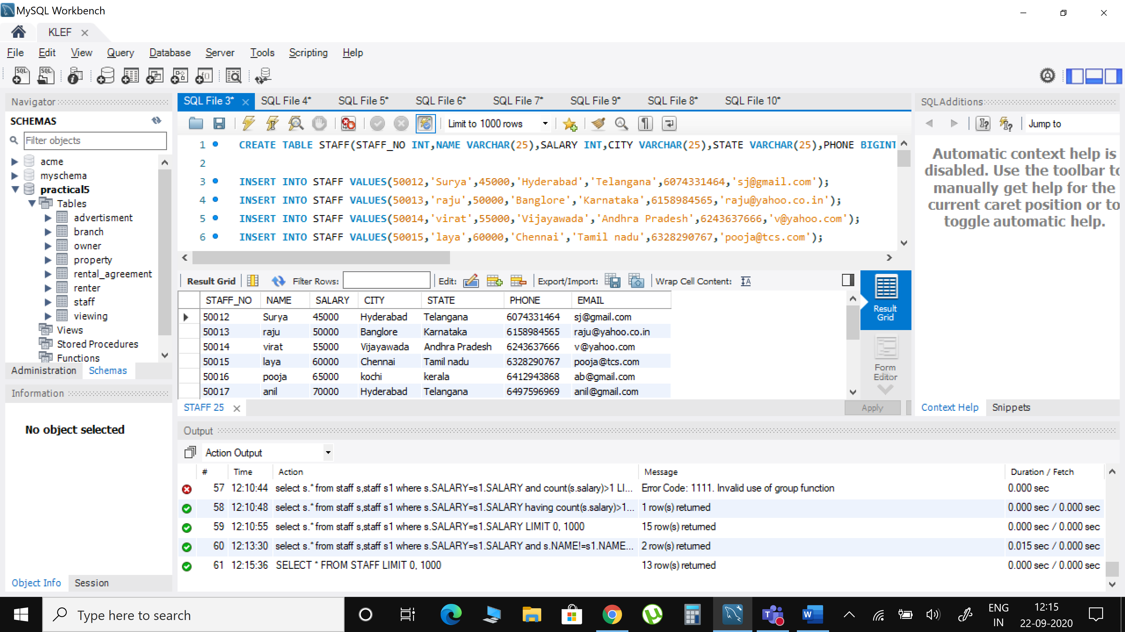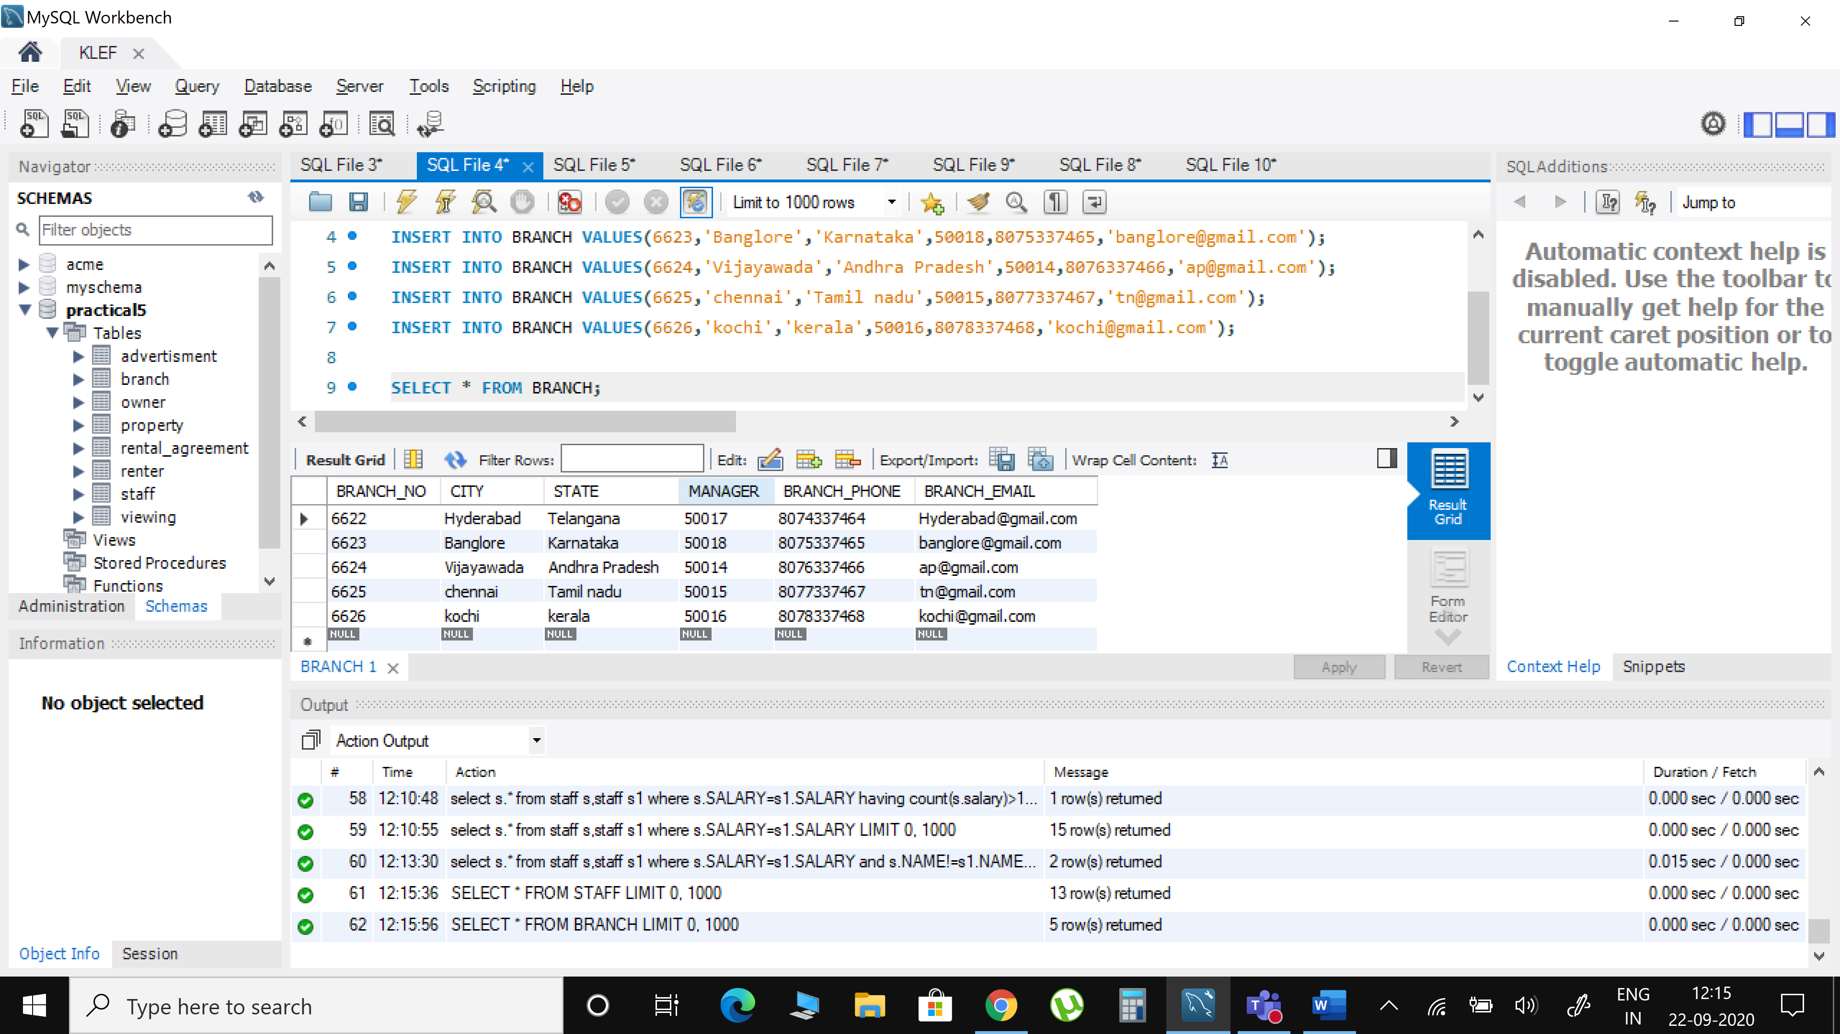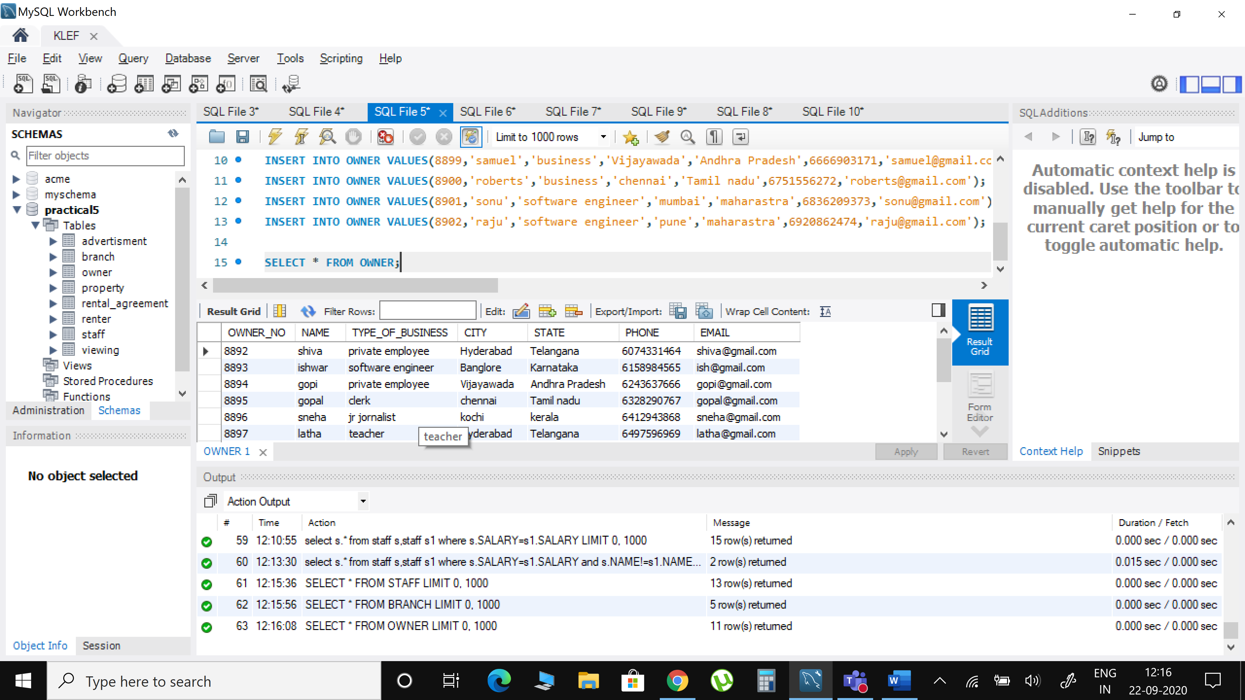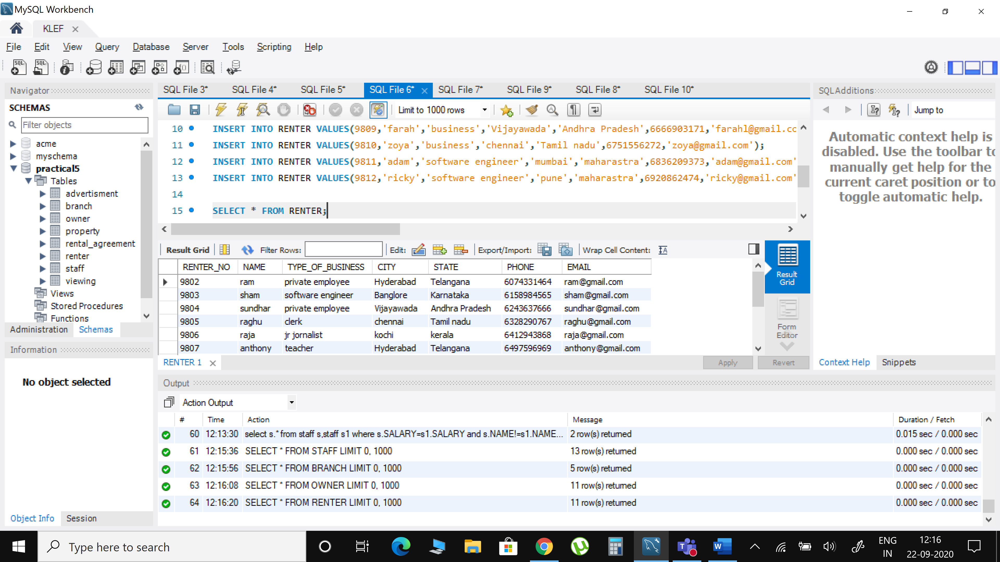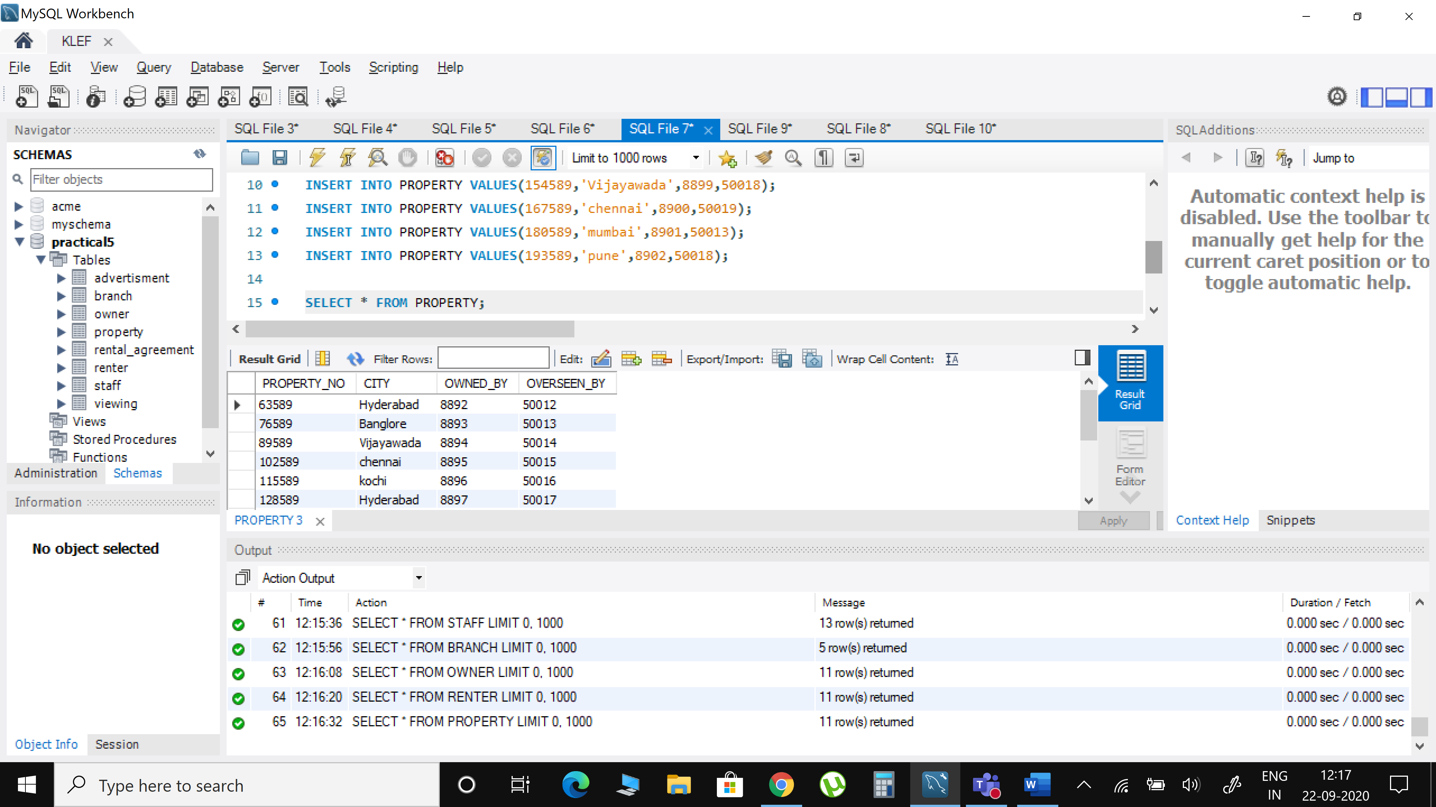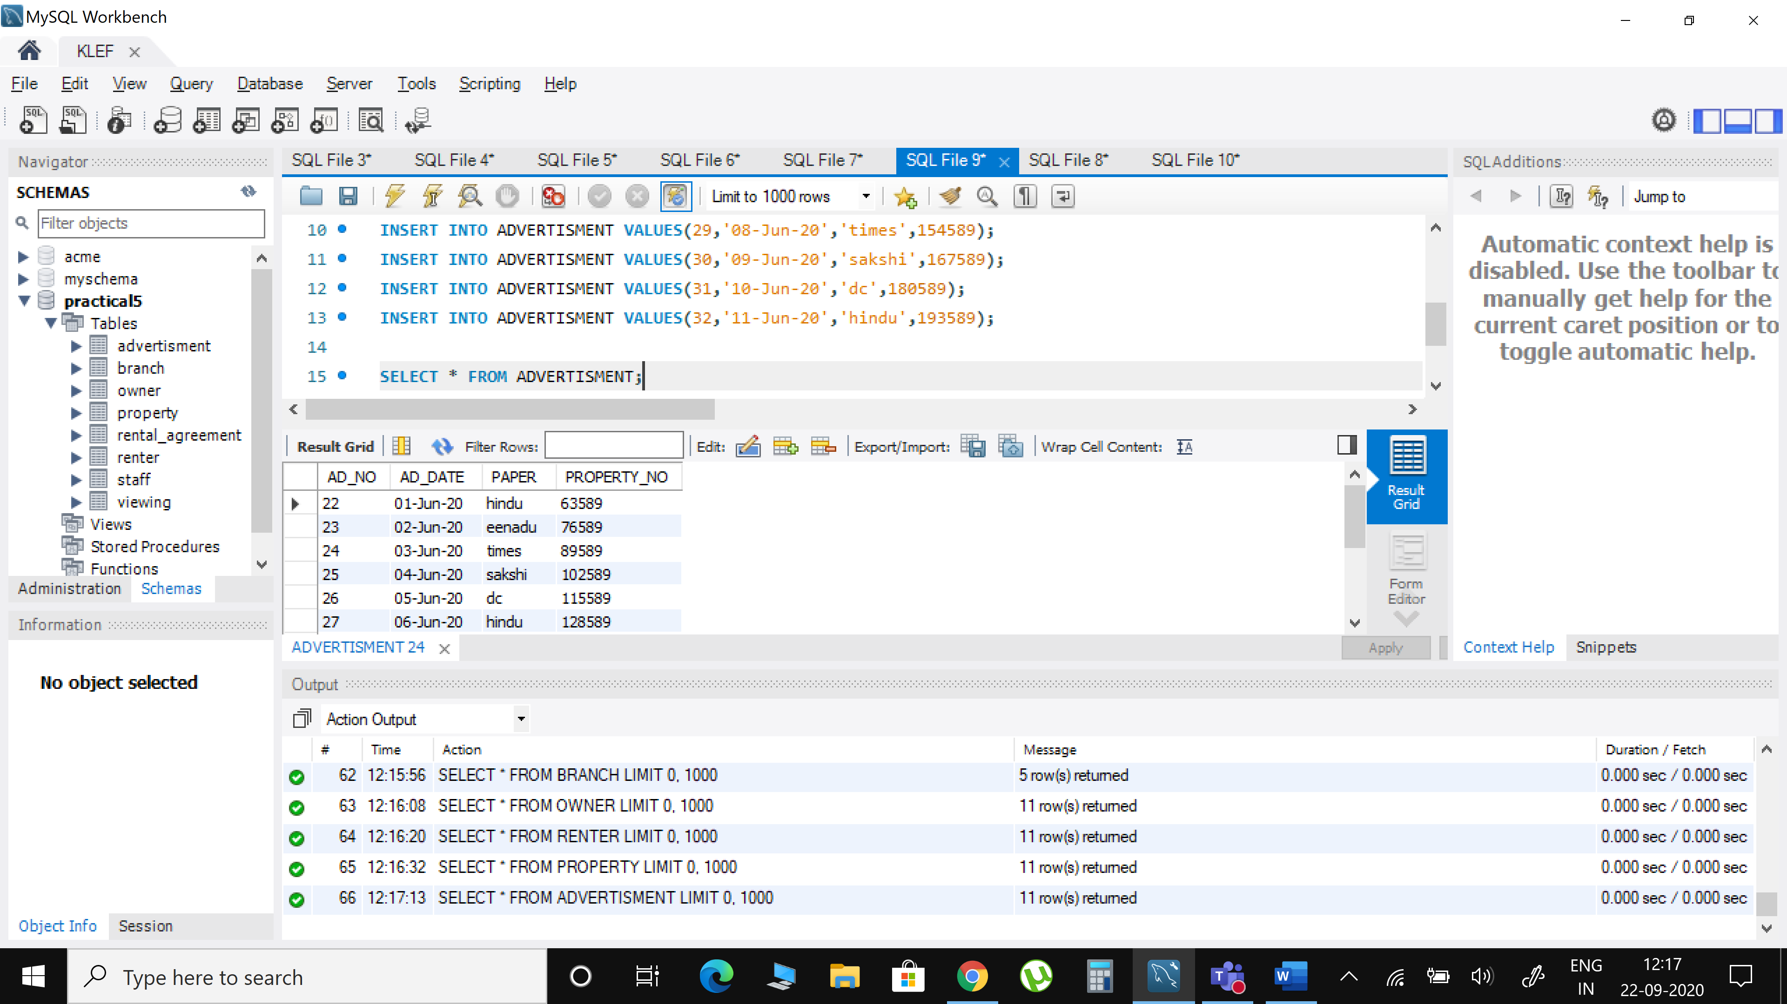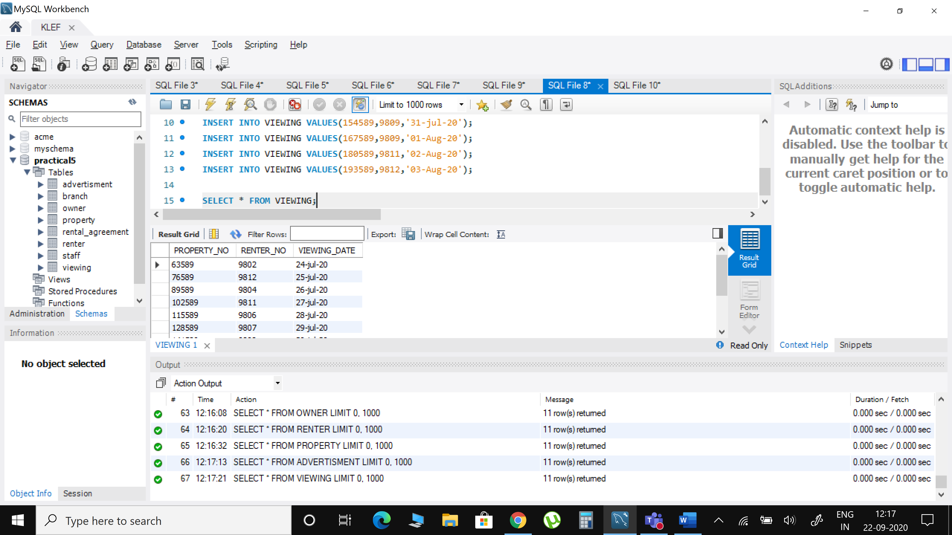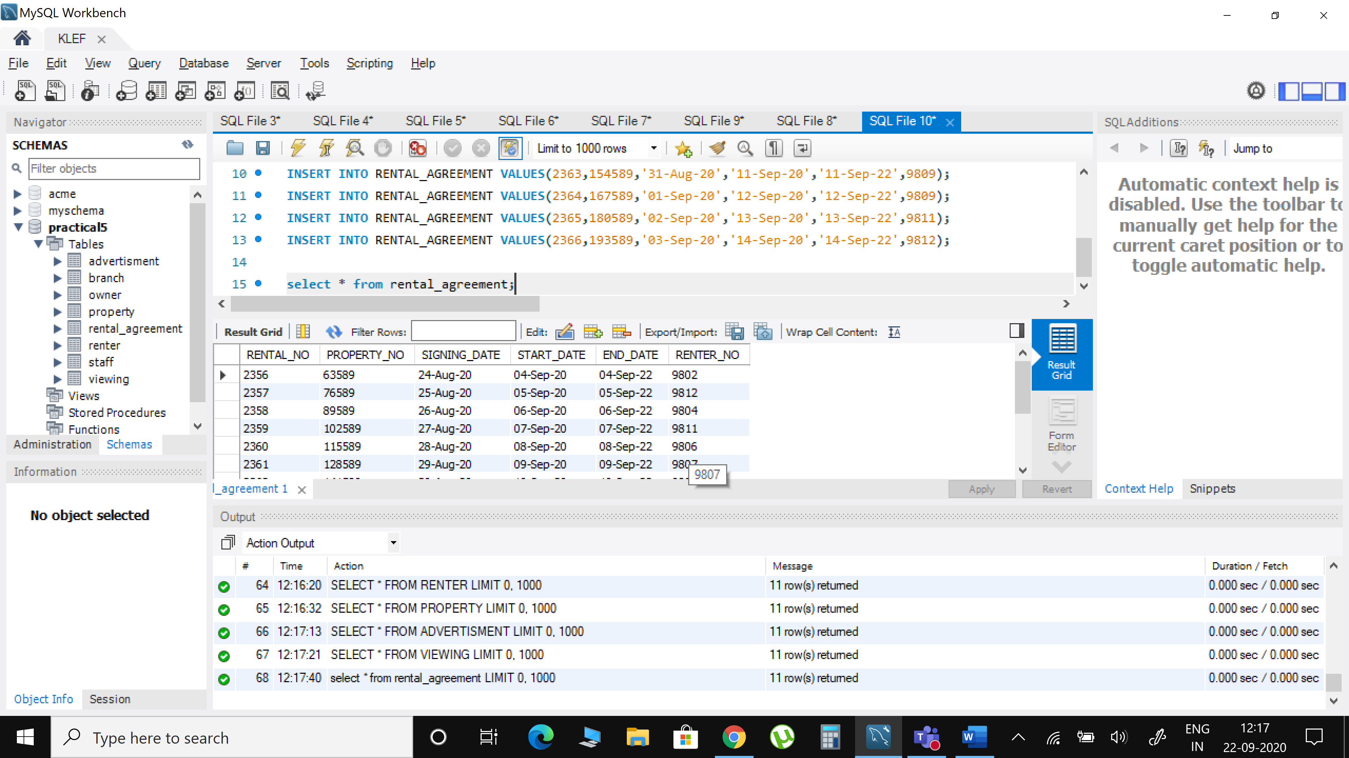

1. Display renter details which are unique.

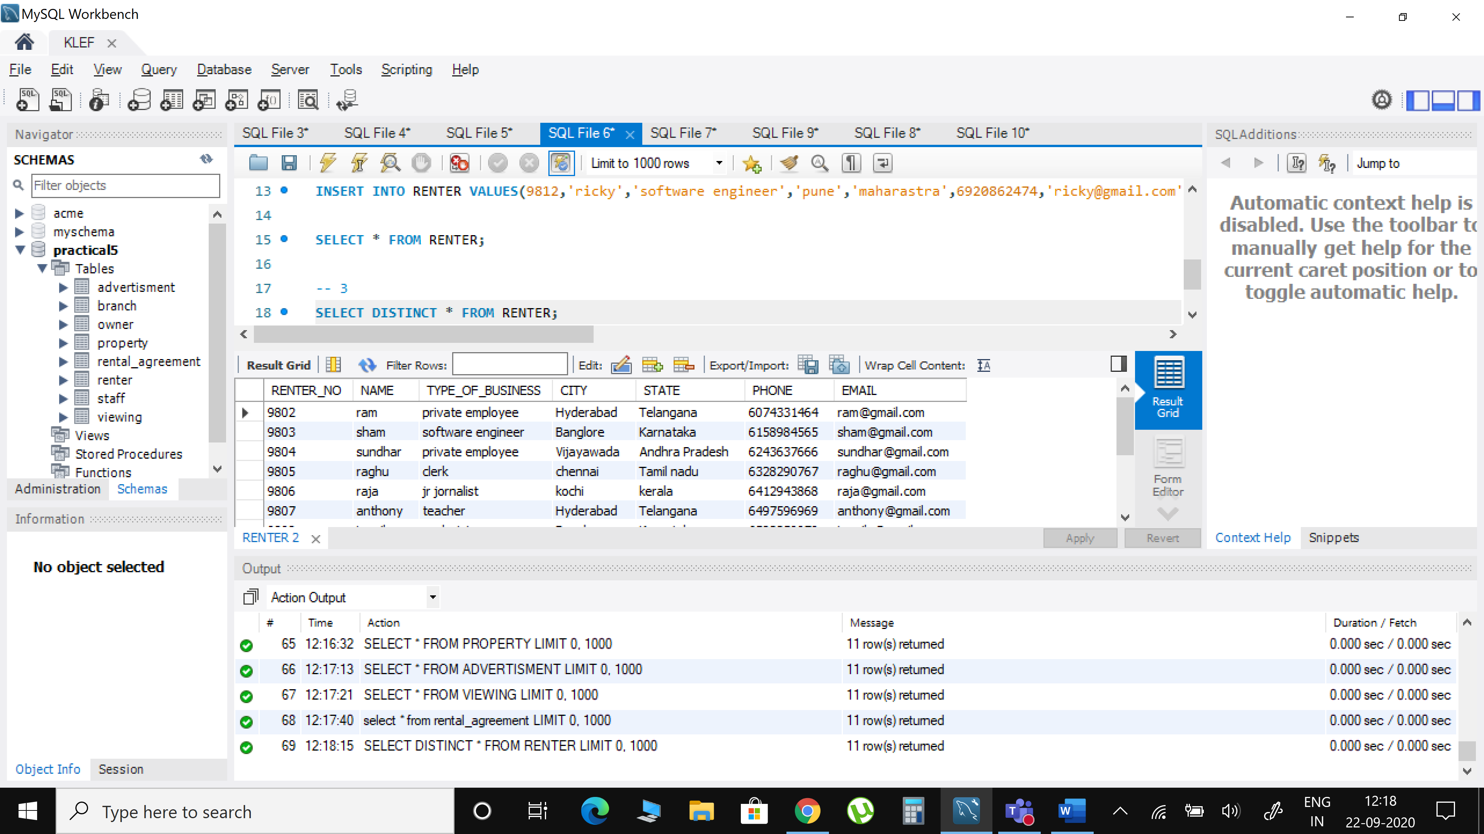

1. Give the email addresses and the renter number for all the private renters. Please, sort them by the renter number.

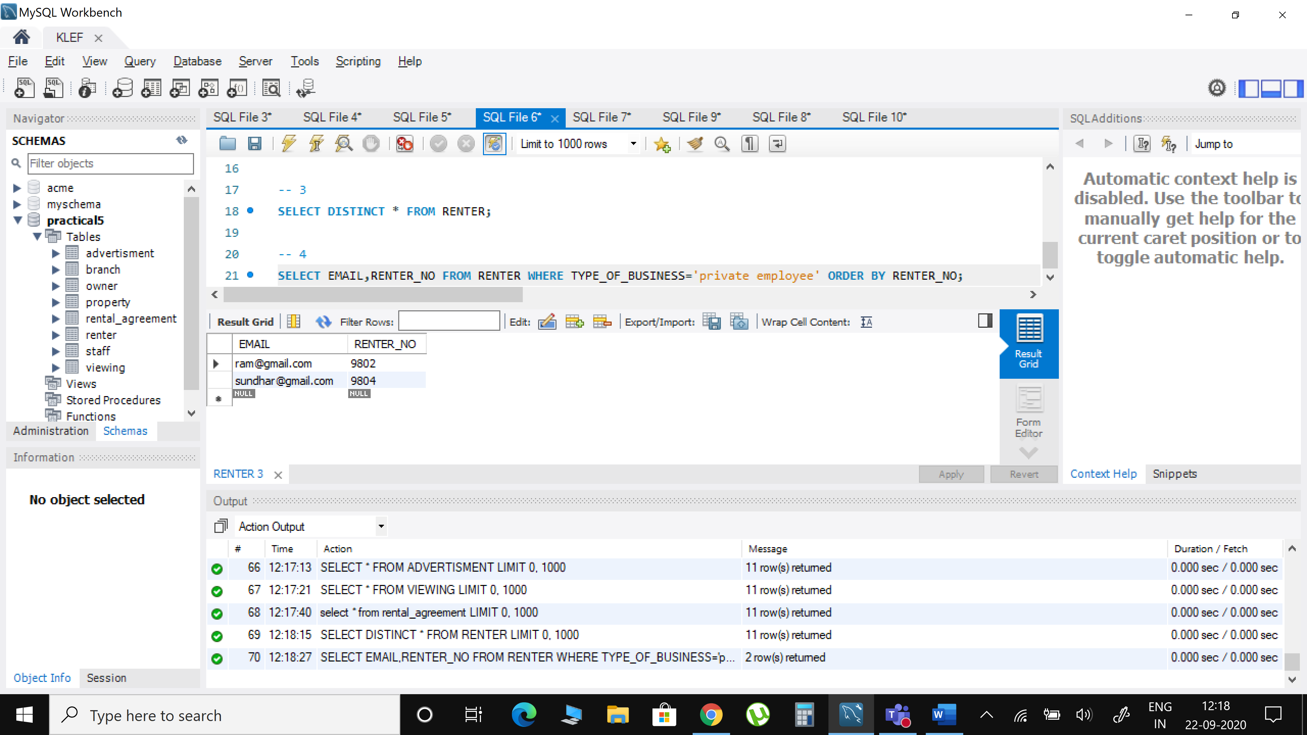

1. Find unique property name and number of branches for each property.

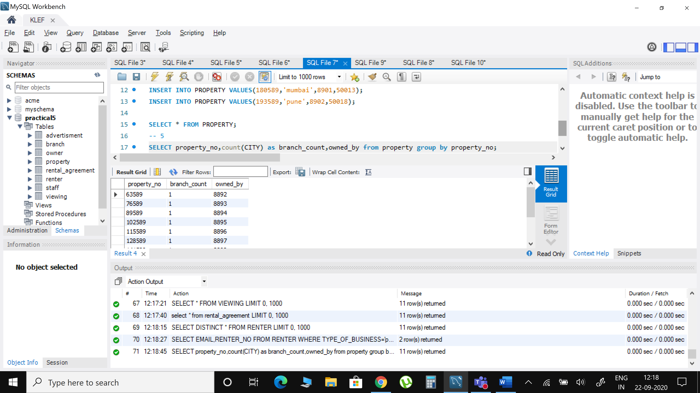

1. Create table for staff member and insert all the details of the staff members.



1. Give the dates of all the advertisements posted in THE GLOBE AND MAIL in 2005.

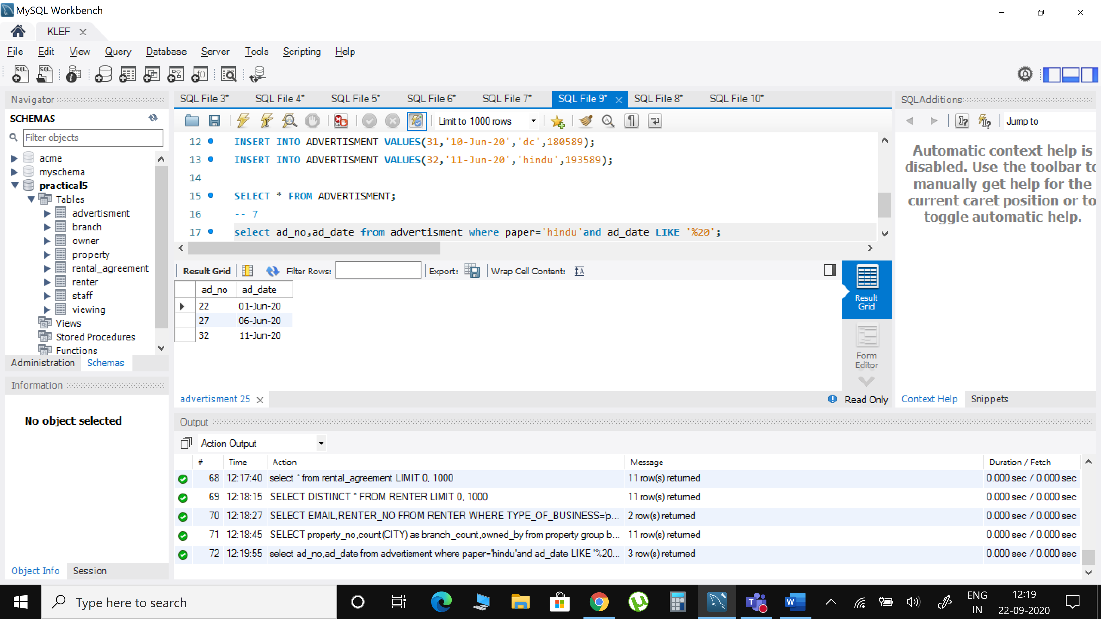

1. Display the count of staff in each branch and display them in descending order on count.

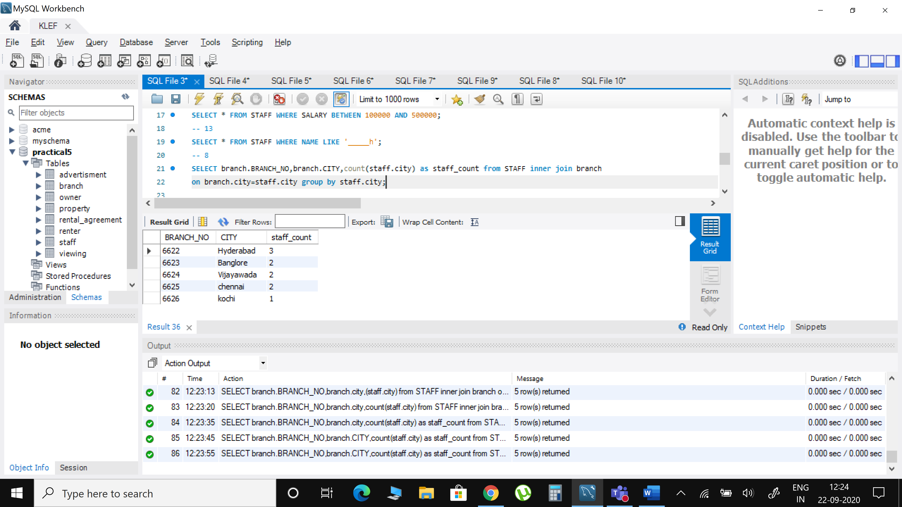

1. Find the properties that are already advertised but not yet rented.

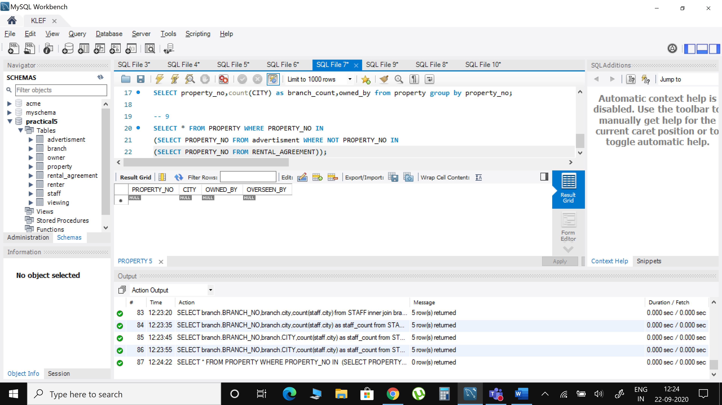

1. Assuming that each advertisement costs 100 dollars, give the branch number and the amount spent on the advertisements for each branch. Name the branch number as Branch no, and the amount as ad cost.

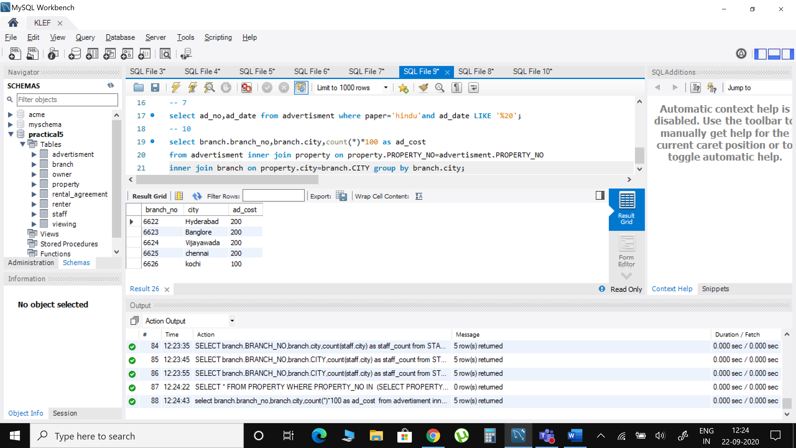

1. Display the details of staff who are working in a particular branch.

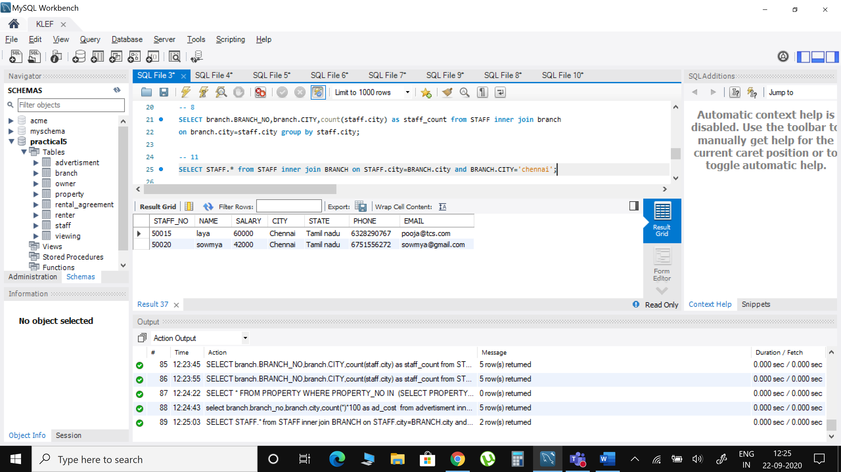

1. Write down a query to find out the Name, Address and Position of the branch staff whose salary is the second highest without using TOP or limit method.

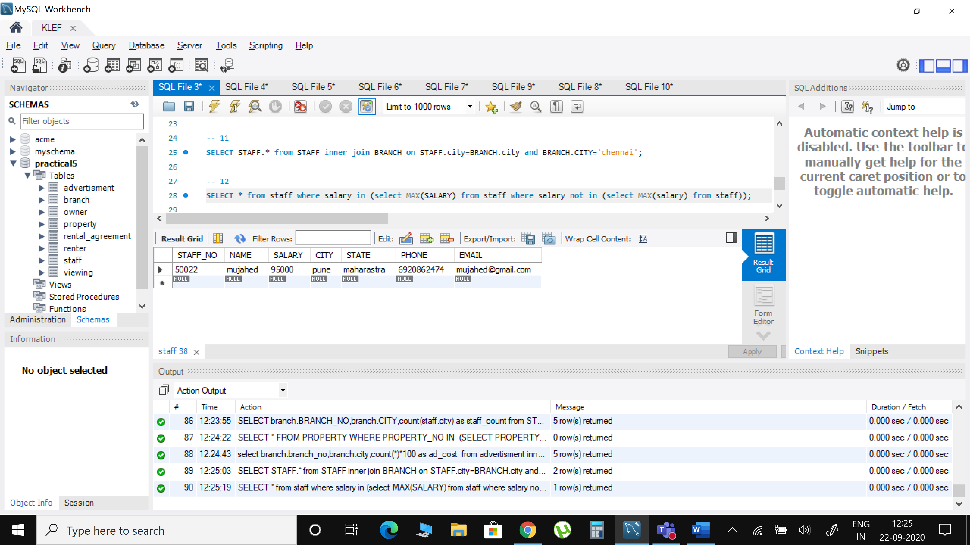

1. Write a query to print details of the staff whose Name ends with ‘h’ and contains six alphabets.

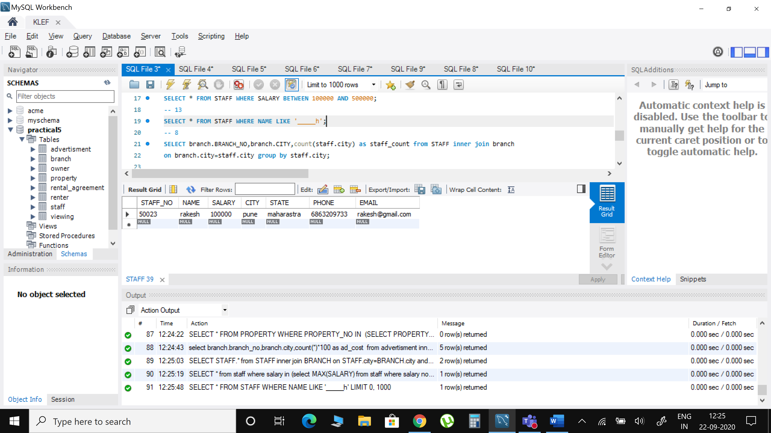

1. Write a query to print details of the staff whose SALARY lies between 100000 and 500000.

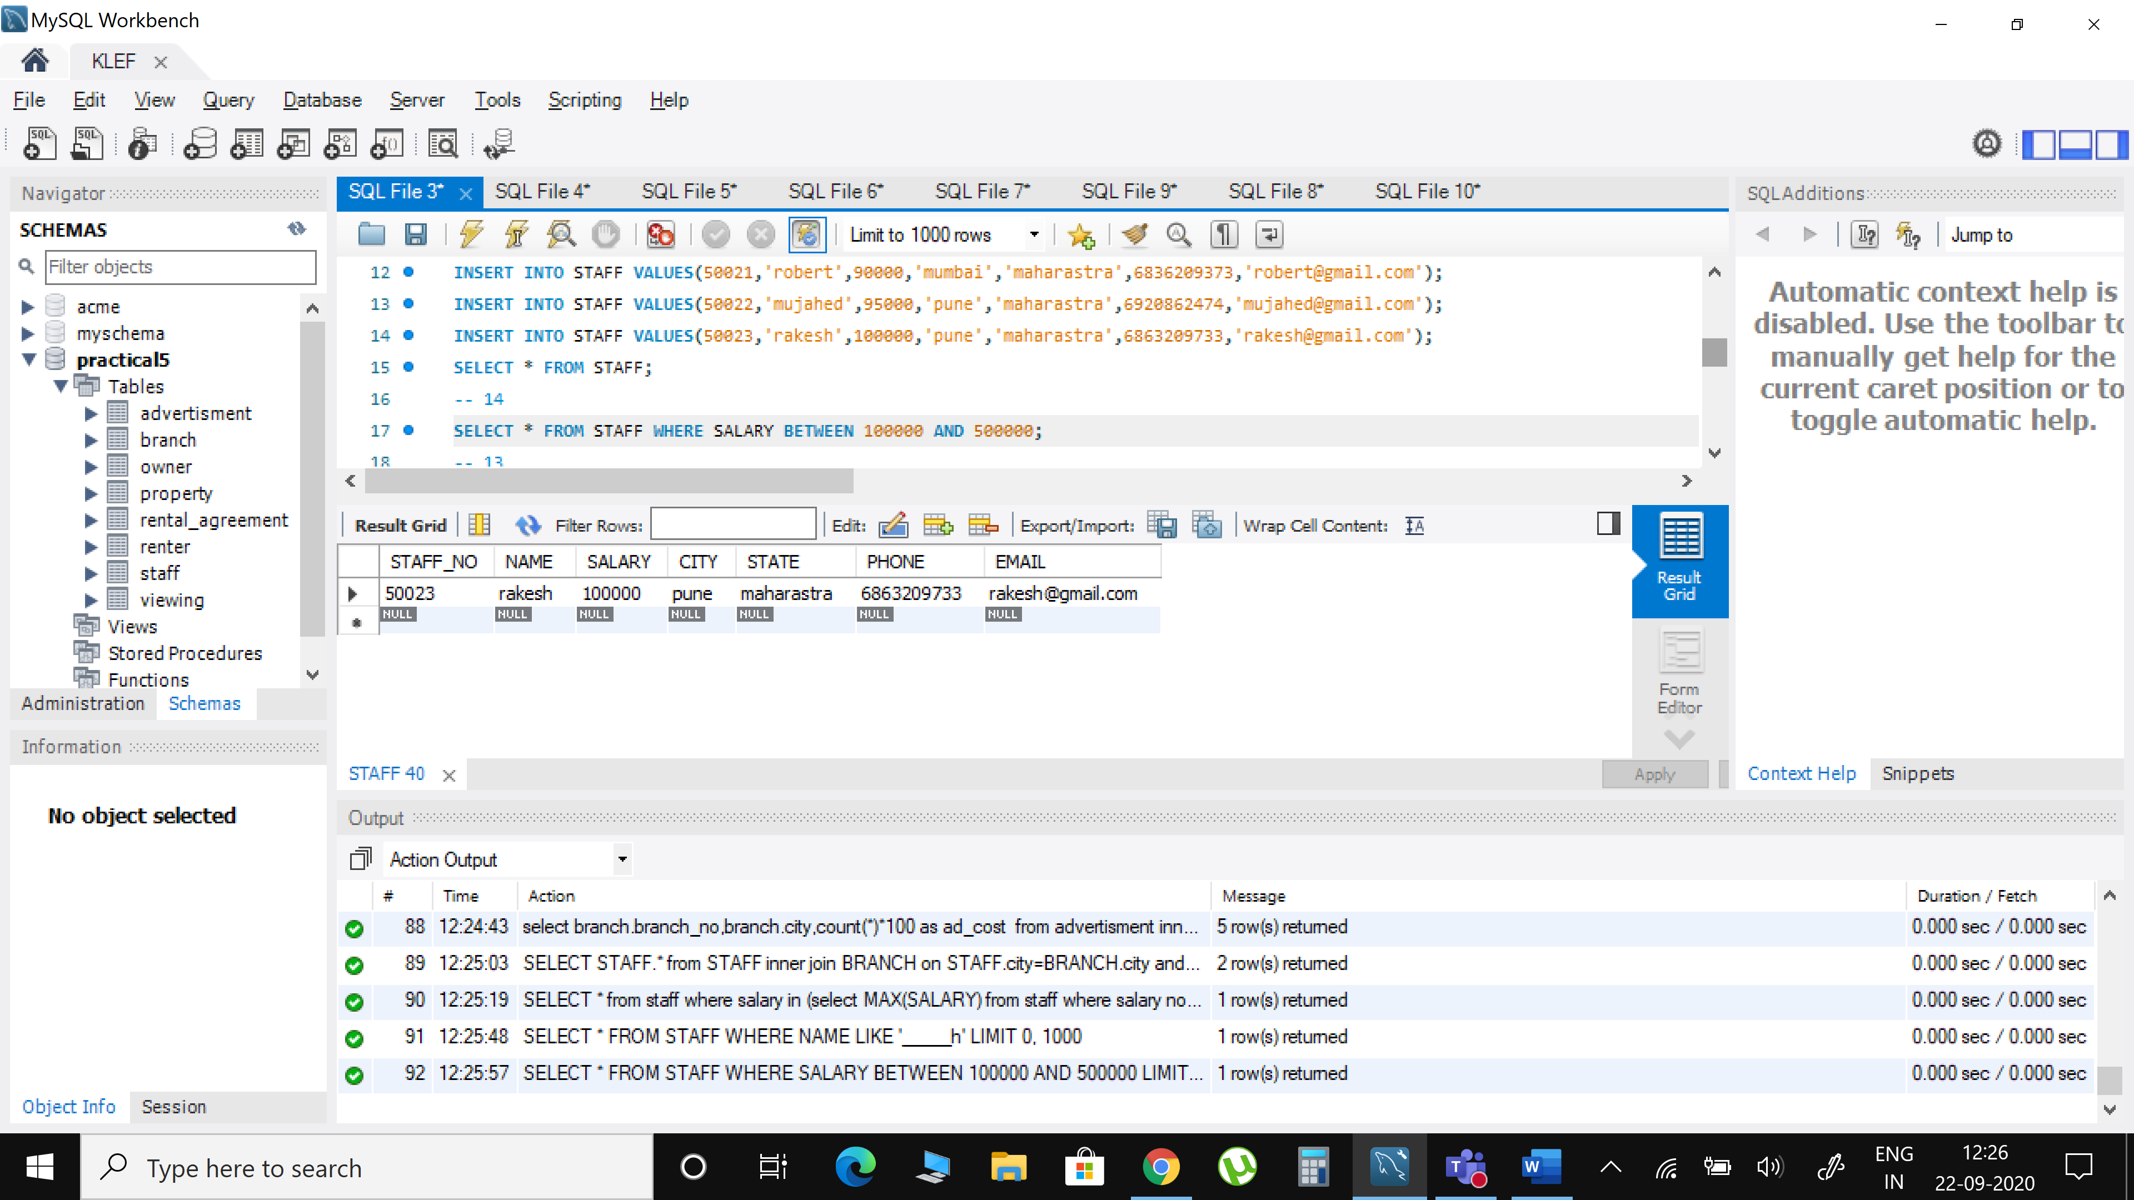

1. Write a query to display the list of employees who draw same salary

